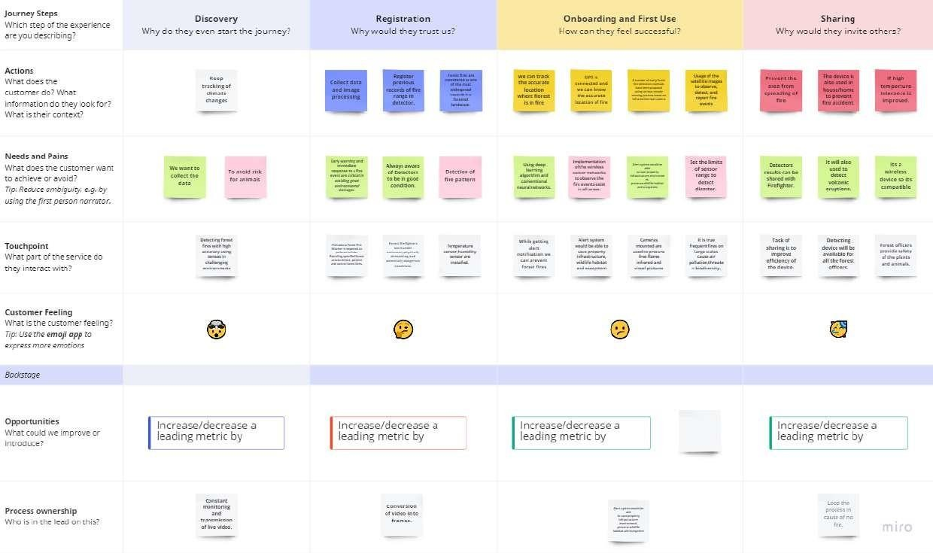Project Design Phase-II Customer journey map

|  |  |
| --- | --- |
| Date | 15 October 2022 |
| Team ID | PNT2022TMID03339 |
| Project Name | Emerging methods for early detection of forest fire |
| Maximum Marks | 4 Marks |